# **Introduction**

### **Problem Statement**

In the modern retail landscape, there is a growing demand for unique, high-quality handmade goods. However, many consumers struggle to find reliable sources for authentic, one-of-a-kind handcrafted items that reflect the craftsmanship and cultural significance of the artisans who create them. On the other hand, many skilled artisans and craftsmen face challenges in reaching a larger number of suitable customers who truly value their work.

.

The key challenges include:

1. **Lack of Connection Between Craftsmen and Consumers**: Despite the increasing demand for handmade products, almost there are not many centralized platforms where consumers seeking unique, artisanal items can easily connect with the artisans who create them. Consumers may spend considerable time searching online or in local markets, only to find limited options.
2. **Visibility and Market Access for Artisans**: Many artisans struggle with limited exposure and marketing resources, hindering their ability to showcase their work to a broader, global audience. As a result, these talented creators are often confined to local markets, missing opportunities to expand their reach and grow their businesses.
3. **Difficulty in Discovering Unique Products**: Consumers who value authenticity and craftsmanship often find it challenging to locate high-quality, handmade items that align with their tastes. The lack of a dedicated platform for showcasing unique crafts leads to missed connections between artisans and buyers who would otherwise be interested in these products.
4. **Fragmented Marketplaces**: Online shopping platforms that focus on handmade goods often fail to provide a seamless, user-friendly experience for both buyers and sellers. The fragmentation of the marketplace leads to confusion, and consumers may not know where to find trustworthy artisans or reliable products.
   * Examples of fragmented marketplaces in the context of handmade goods include.
5. **Social Media Channels** (e.g., **Facebook**, **Instagram**): Many artisans and small businesses in Egypt use social media to sell their products. While these platforms offer visibility, they are not dedicated marketplaces, leading to scattered buyer-seller connections and difficulty in discovering reliable vendors.
6. **Souq.com/Daraz (now Amazon Egypt):** While these platforms host a variety of products, they are not specialized in handmade or artisanal goods. As a result, artisans struggle to stand out, and consumers searching for unique crafts may find limited options or face challenges locating high-quality handmade items.
7. Immigrant pages or groups: Many emerging websites or Facebook groups cater to specific types of crafts, such as jewelry or pottery. However, these are often fragmented, lack effective search features, and do not provide a unified platform to showcase diverse materials.
8. Open Marketplaces Like OLX Egypt: OLX is used to manufacture various products, including products that are not handcrafted by artisans. It operates on sections or filters dedicated to handcrafted work, making it difficult for consumers to find products that are made or of high quality.

This scattered setup makes it challenging for artisans to reach a broad audience and for consumers to find a variety of unique products in one convenient location.

1. **Trust and Verification Issues**: Consumers may be hesitant to purchase handmade products online due to concerns about the authenticity of the items, the credibility of the sellers, and the overall quality of the goods.

### **Solution Overview**

This online shopping platform seeks to solve these issues by creating a dedicated space for consumers seeking unique, handcrafted products and artisans looking to reach a wider audience. The platform will address the following key needs:

* **Bringing Together Craftsmen and Consumers**: By offering a centralized marketplace, the platform will make it easier for consumers to discover and connect with artisans who create handmade goods, ranging from jewelry and clothing to home decor and artwork.
* **Increased Visibility for Artisans**: Artisans will have the opportunity to showcase their products to a global audience, significantly increasing their visibility and chances of connecting with buyers who appreciate handmade, unique items.
* **Streamlined User Experience**: The platform will provide an easy-to-navigate, seamless browsing and shopping experience, allowing consumers to find products based on categories such as materials, type of craft, cultural significance, or price range.
* **Trust and Transparency**: With features like detailed product descriptions, customer reviews, and secure payment options, the platform will ensure that both consumers and artisans can engage with confidence and trust.
* **Support for Artisans’ Growth**: The platform will offer tools to help artisans manage their products, track sales, and receive customer feedback, allowing them to improve their offerings and grow their businesses effectively.

### **Conclusion**

This online shopping website aims to create a thriving community where artisans and consumers can easily connect, share, and discover unique handmade products. By addressing the challenges of visibility, trust, and ease of access, the platform will not only empower artisans to expand their reach but also provide consumers with a rich, diverse marketplace for finding authentic, one-of-a-kind handmade goods. The ultimate goal is to foster a more sustainable and meaningful connection between creators and buyers, celebrating the beauty and craftsmanship of handmade goods in a digital marketplace.

## Scope

our e-commerce website project involves creating a complete online store with a wide range of products in different categories. This project will include features like allowing users to sign up, managing the list of products, letting customers add items to a cart, ensuring safe payment, and giving users a personalized shopping experience and more. The goal is to make a website that works well on different devices, keeps customer information safe, and is easy for people to use. It will also follow rules about protecting customer data and will offer many useful shopping features.

As part of the scope, the website is currently focused on operating within Egypt. It will cater to local artisans and customers in addition to tourists, with future plans to expand its reach to international markets in subsequent phases.

### **Target Audience**

**Artisans and Craftsmen**: Individuals or small businesses producing handmade goods, including

* + **Demographics:**
    - Age: 18-65+ (a wide range, as craftspeople can be of various ages)
    - Gender: Both male and female
    - Location: around Egypt
  + **Psychographics:**

**Values:**

* **Quality and Craftsmanship:** Appreciates high-quality, handmade products.
* **Authenticity:** Prefers genuine, original pieces over mass-produced items.
* **Sustainability:** Values eco-friendly practices and sustainable materials.
* **Unique and Personalized:** Seeks one-of-a-kind items that reflect their individuality.
* **Supporting Local Businesses:** Enjoys contributing to local economies and supporting small businesses.

**Interests:**

* **Arts and Crafts:** Enjoys exploring different art forms and creative expressions.
* **Home Decor:** Interested in unique and stylish home decor items.
* **Fashion and Accessories:** Seeks unique and personalized fashion accessories.
* **Gifts:** Loves giving thoughtful and personalized gifts.

**Behaviors:**

* + - Online presence: Active on social media or other online platforms to showcase their work
    - Business mindset: Open to selling their products online and reaching a wider audience
* **Consumers:** People interested in unique, high-quality handmade products who value craftsmanship, culture, and sustainability.
  + **Demographics:** 
    - Age: 18-65+
    - Gender: Both male and female
    - Location: around Egypt
  + **Psychographics: (interest, personality& values)**
    - **Interests:** 
      * Art, design, unique items, sustainability, supporting local businesses
    - **Values:** 
      * Quality, authenticity, originality, ethical consumption
    - **Behaviors:** 
      * **Online shopping behavior:** Active online shoppers, particularly on e-commerce platforms

### Operating Environment

Web Application running on the browser with a responsive design suitable for desktop view and mobile view and a iOS Mobile version

## Core functions

#### For customer

* **Register:**
* **Login /Logout**
* **View** personal and artesian accounts
* **Edit** personal Account Details ()
* **Search** / **filters** to refine search results
* **View item**
* **Add**/**remove** item to cart
* **Add**/**remove** item to wish_list
* **View shopping cart**
* **Payment transactions (pay/money_back)**
* **Track order**
* Return item
* **Rate item**
* **Review item**
* **direct communication** with sellers
* Use Chabotto resolve issues
* **View receipts**
* **Choose preferred language**
* **Sharing through social media**
* **Choose** **shipping options** based on their preferences. (delivering on shop/ getting it delivered)

#### Delivering company

* Receive order details
* Provide **shipping updates**

#### For seller

* Register / **Create detailed artisan profiles**
* Login /Logout
* View /Edit Account Details
* Search item
* View item
* Manage **inventory** via a **dashboard**. (add, edit, remove)
* Delivery & payment
* Track order
* Accept/Cancel order
* Return item
* View orders and returns
* view rates
* View sales detailes
* **direct communication** with sellers
* Offer promotions or discounts.
* Receive **stock alerts**.
* Offer **on-demand products**
* **Receive/send payments via secure gateways**
* **Set shipping preferences**
* **collaborate** with delivery services for logistics.

#### Admin

* Login/Log out
* Manage **review system** and ensure legitimacy of ratings and feedback.
* Oversee the **money-back guarantee** process to verify claims and initiate refunds.
* Approve new products and verify **inventory** status
  1. Oversee collaboration with partners (e.g., seller,hotels, tourism office).
* Control discount codes and special offers
* Monitor inventory levels across the platform.
* Approve new products and verify **inventory** status.
* Offer **incentives** and support **training programs** for artisans.

#### System

* Display **product reviews and ratings**.
* Support **payment gateways** (e.g., Stripe, PayPal).
* Provide automated notifications about **pays**/**money-back guarantee** policies.
* Integrate **media uploads** for product listings.
* Integrate with **shipping API** for tracking and updates for Provide **pickup point details** for Tourists
* **switch language** based on the user’s preferences
* Offer a multilingual **customer support** system (either chatbots or human agents)
* Implement **search filters** for product categories and features
* Display **special offers** and **discount campaigns**.
* Integrate **social media sharing** options.
* Update **inventory levels** in real-time.
* Display **product specifications** and enable **Q&A sections**
* Provide a **user-friendly interface**.
* View **stock availability**
* Display **best-rated products** and **product comparison features and person recommendations**

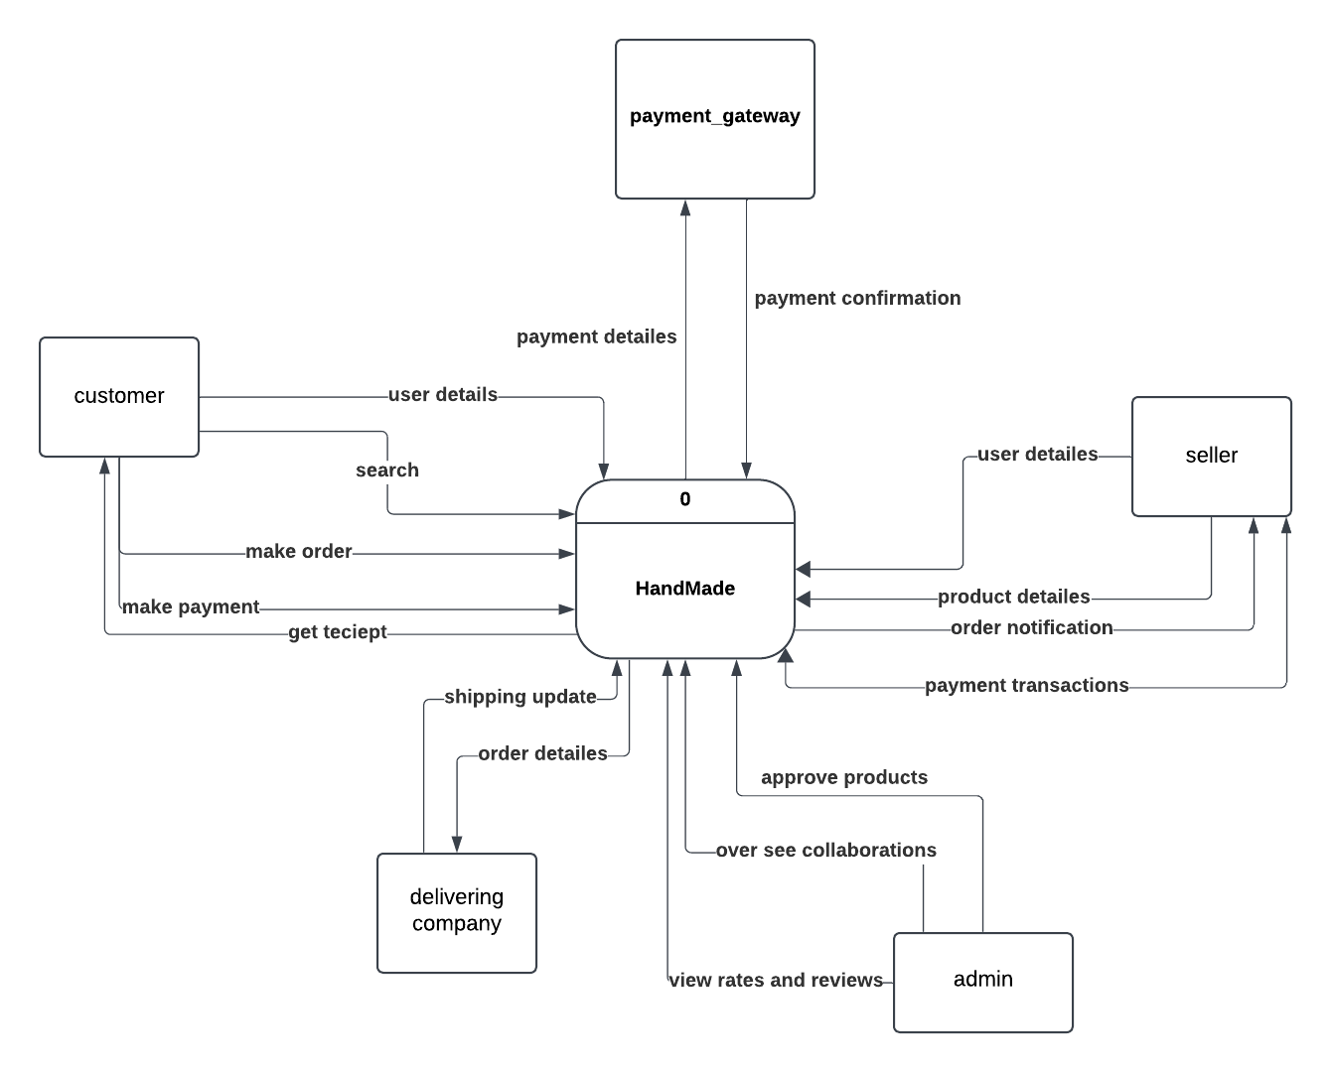

## Definitions and acronyms:

Key terms and abbreviations used in the documentation.